1. Library Management System
Aim:
To develop a simple Library Management System for managing books, users, issue/return details, fines and study materials.
Algorithm:
- Start the Library Management System.
- Allow users and librarian to register/login.
- Allow librarian to add, update, delete and view books.
- Allow users to search and borrow books.
- Maintain issue and return details.
- Calculate fines for late returns.
- Display borrowing history and study materials.
- Stop.
Program:
<!DOCTYPE html>
<html>
<head>
<title>Library Management System</title>
<link rel="stylesheet" href="style.css">
</head>

<body>

<h1>Library Management System</h1>

<!-- LOGIN PAGE -->

<div id="loginPage">

<h2>Student Login</h2>

<input type="text" id="username" placeholder="Username">
<input type="password" id="password" placeholder="Password">

<button onclick="login()">Login</button>

</div>

<!-- LIBRARY PAGE -->

<div id="libraryPage" style="display:none;">

<h2>Welcome to Library</h2>

<h2>Search Book</h2>

<input type="text" placeholder="Enter book name">
<button>Search</button>

<h2>Available Books</h2>

<table>

<tr>
<th>Book</th>
<th>Author</th>
<th>Status</th>
</tr>

<tr>
<td>Python</td>
<td>Guido</td>
<td>Available</td>
</tr>

<tr>
<td>Data Structures</td>
<td>Mark</td>
<td>Available</td>
</tr>

</table>

<h2>My Borrow History</h2>

<p>Book: Python</p>
<p>Issue Date: 01-10-2026</p>
<p>Return Date: 15-10-2026</p>
<p>Fine: ₹0</p>

</div>

<script>

function login() {

let name = document.getElementById("username").value;
let pass = document.getElementById("password").value;

if (name == "devi" && pass == "1234") {

alert("Login Successful");

document.getElementById("loginPage").style.display = "none";

document.getElementById("libraryPage").style.display = "block";

}
else {

alert("Invalid Username or Password");

}

}

</script>

</body>
</html>
Output:
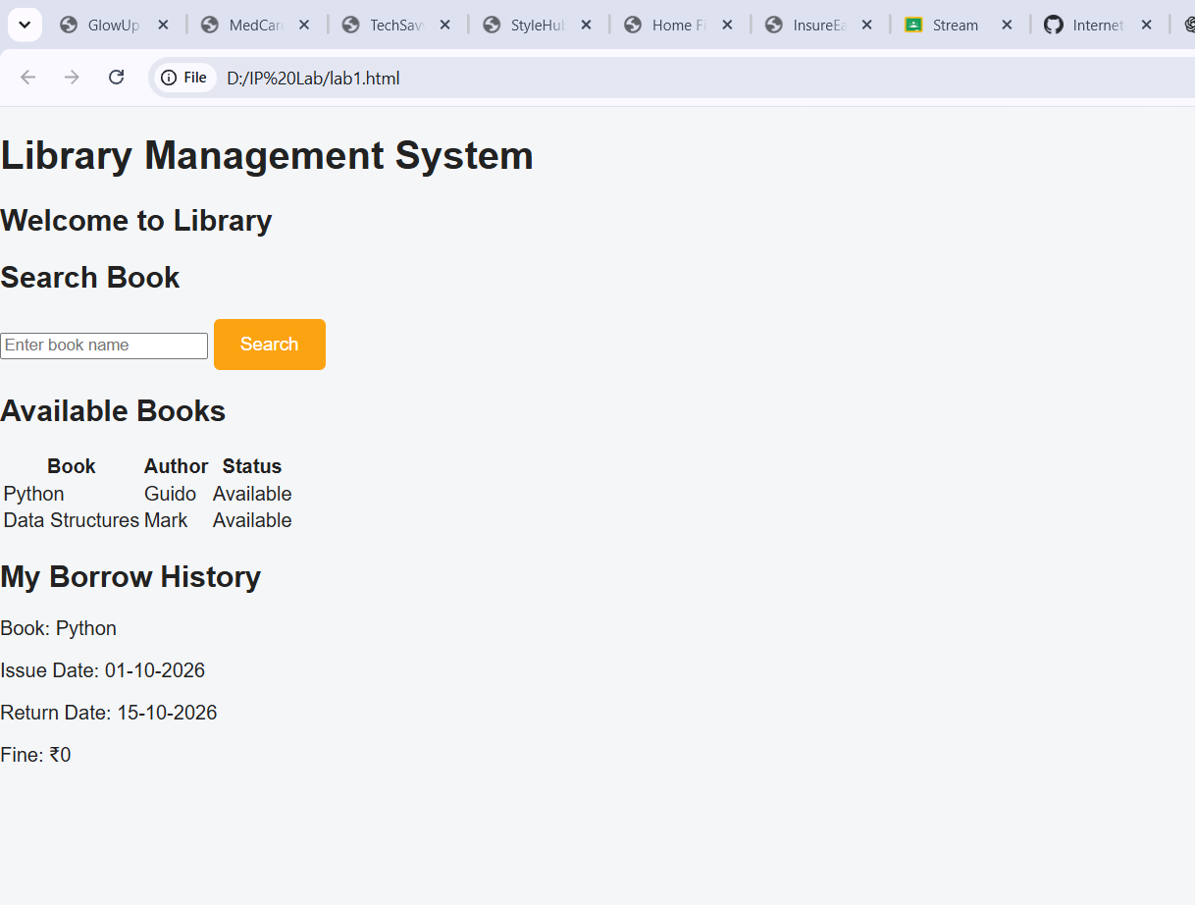
Result:
Thus, the Library Management System was successfully developed to manage books, users, issue/return details and fines. INTERNET PROGRAMMING LAB EXPERI…

